Module 4 Assignment  
  
Q1. Create a local branch using git checkout -b branchname command  
A1. git checkout –b newBranch

Q2. Observe the difference by doing some file operations and switch back to the master branch and see if you can see the changes done on the branch  
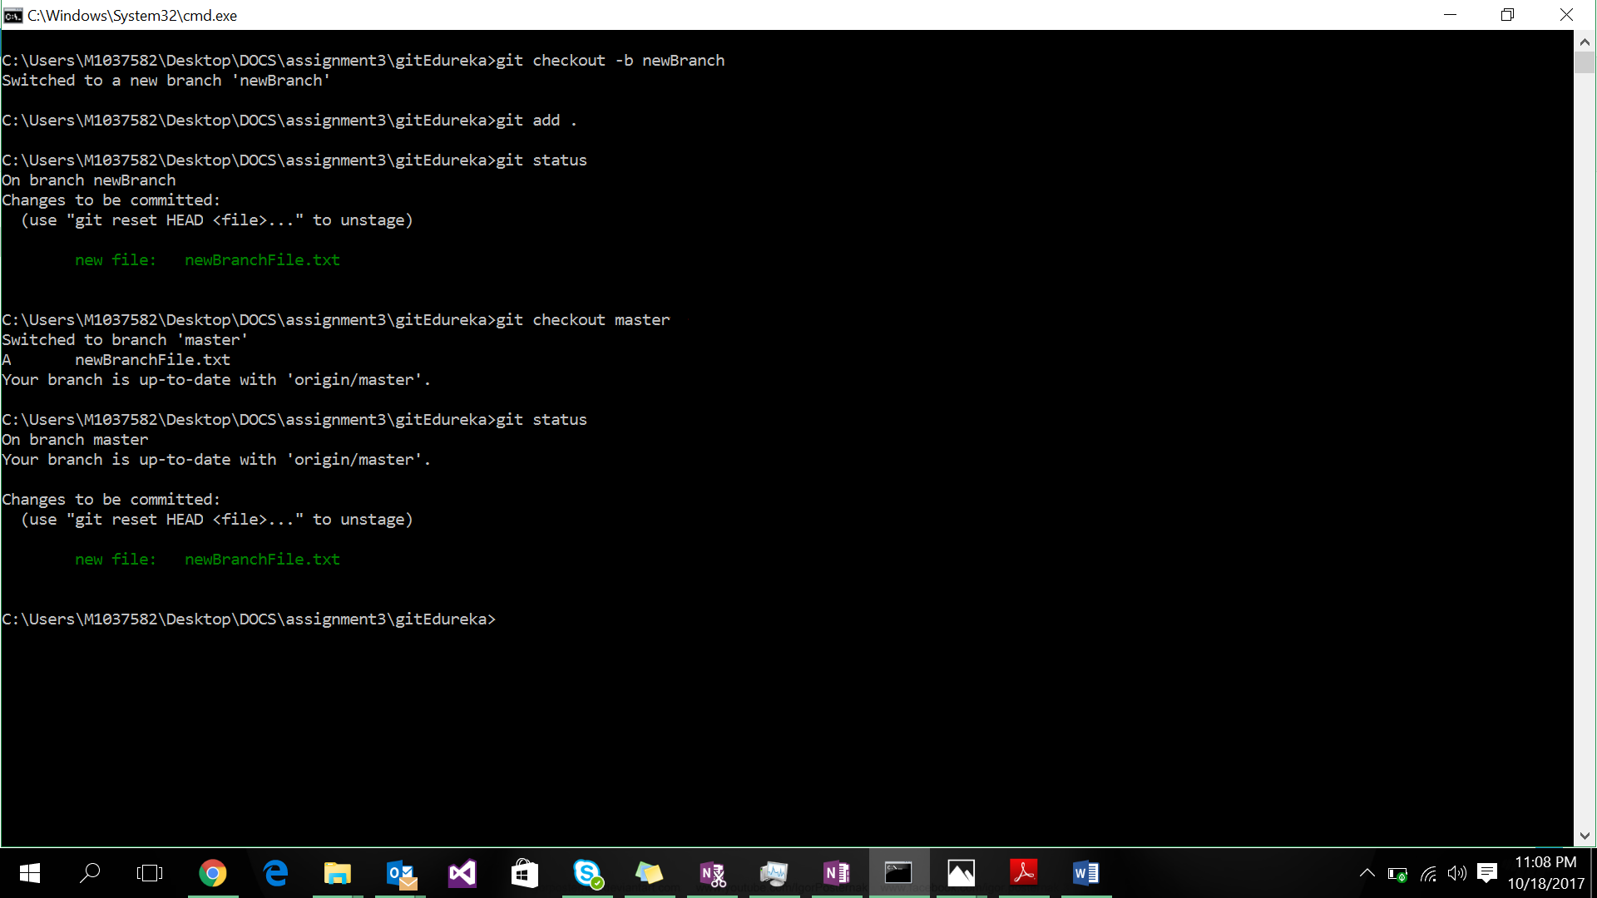

Q3. Now switch back to the branch and commit the changes and switch to master branch. Now see if you can still see the changes in the master branch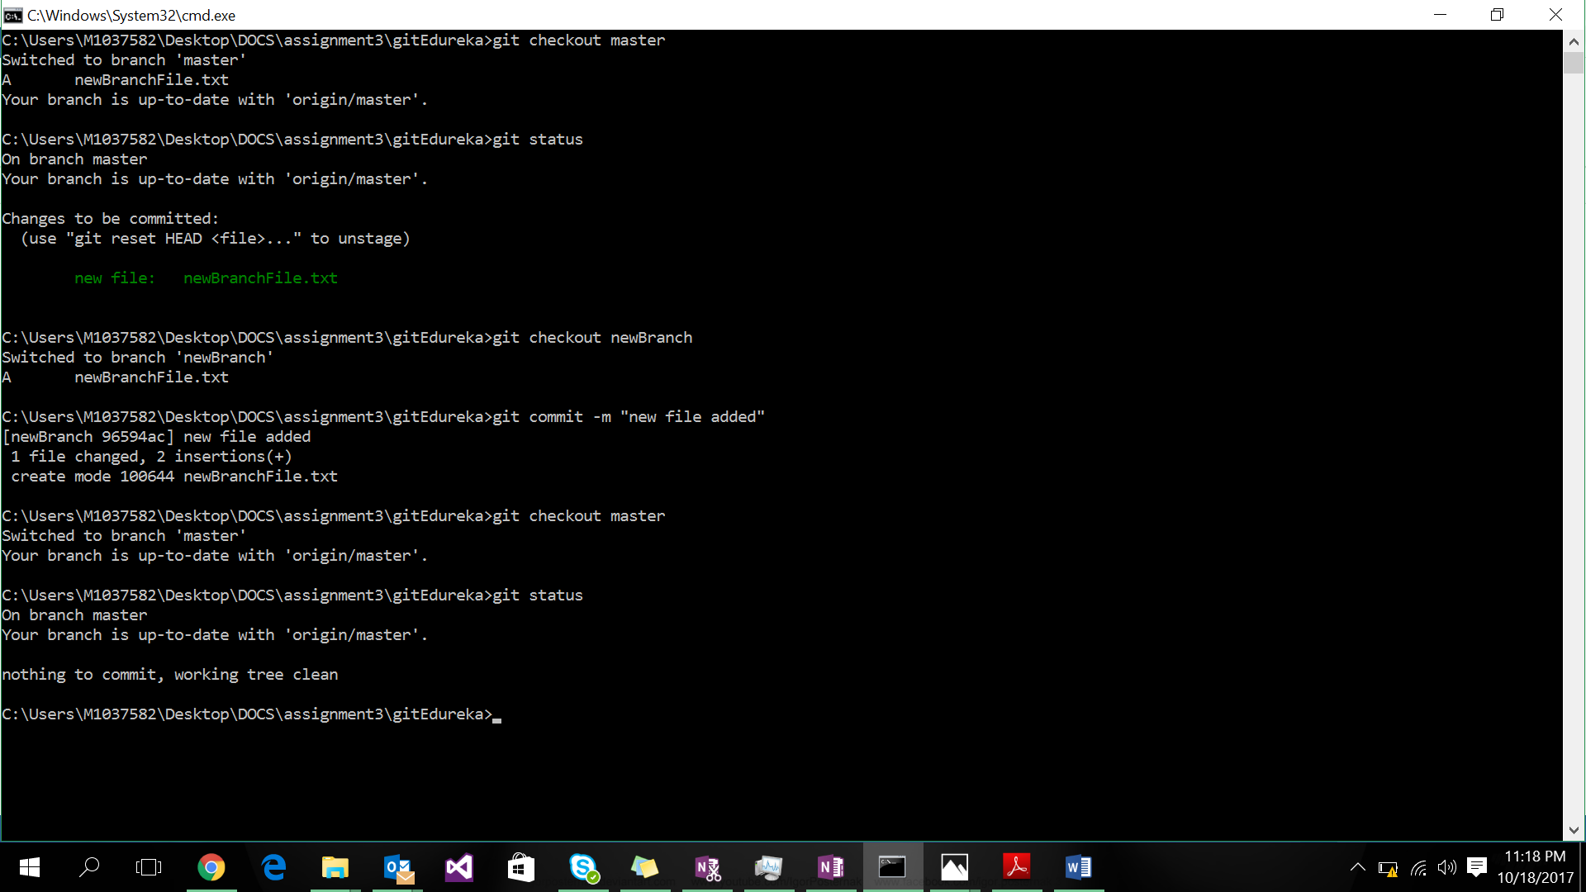

Q4. Now switch back to the branch name and stash the changes and apply the changes to the master branch by switching to the master branch

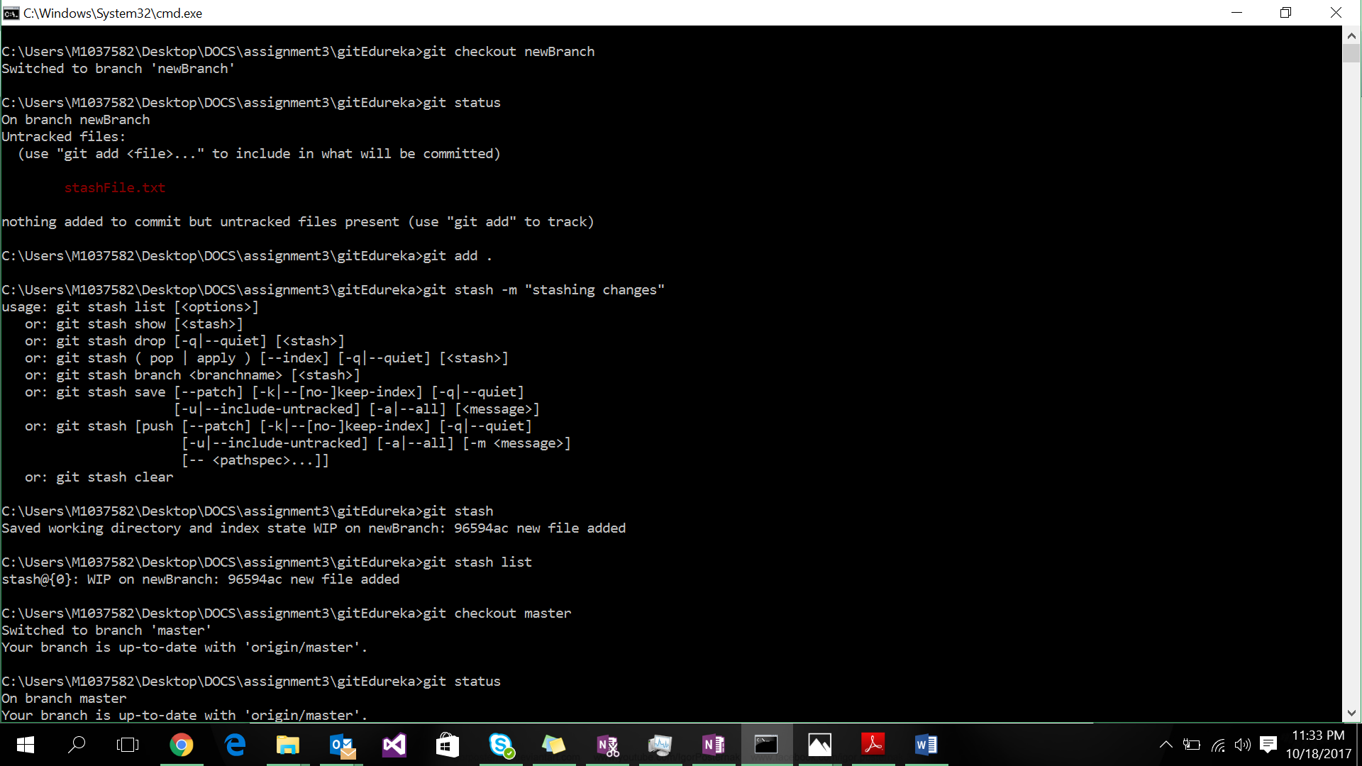

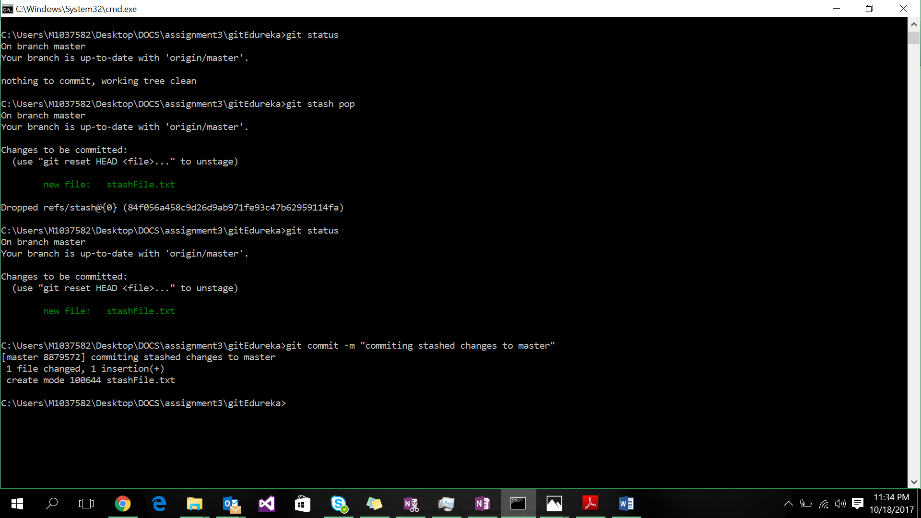

Q5. Try merging the changes from the branch to the master branch using all the three merge strategies and then view the git log

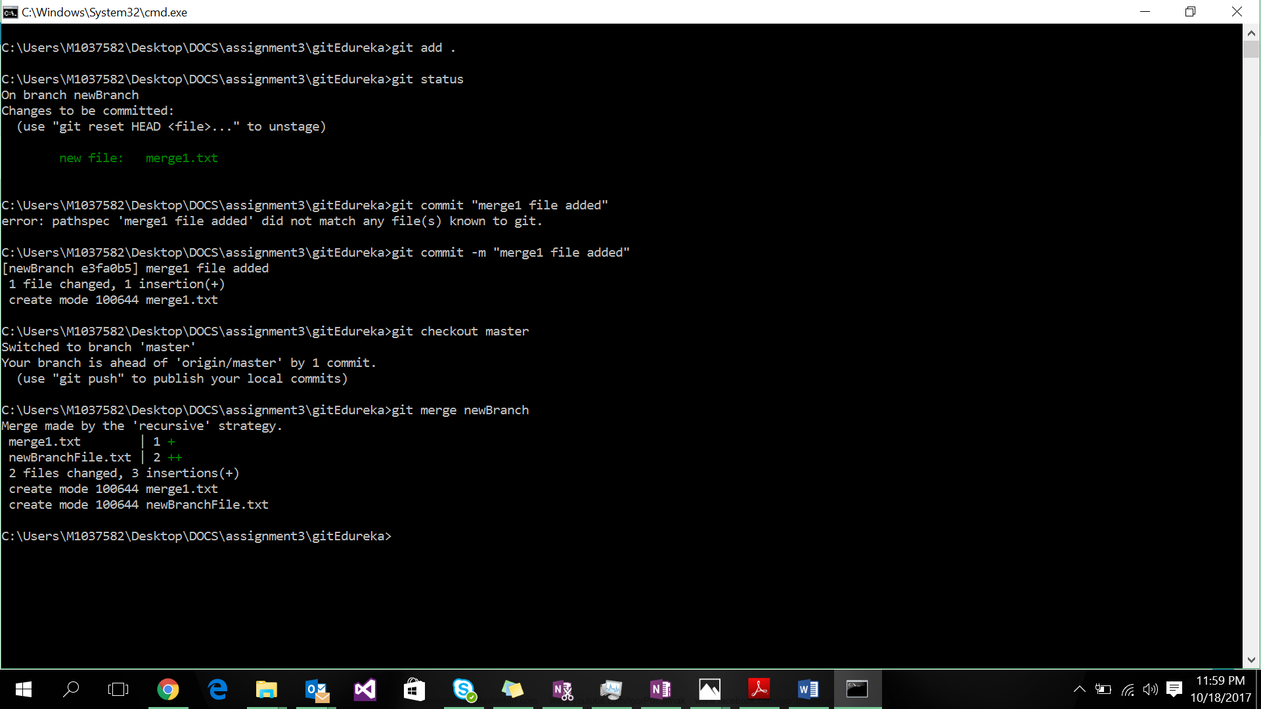

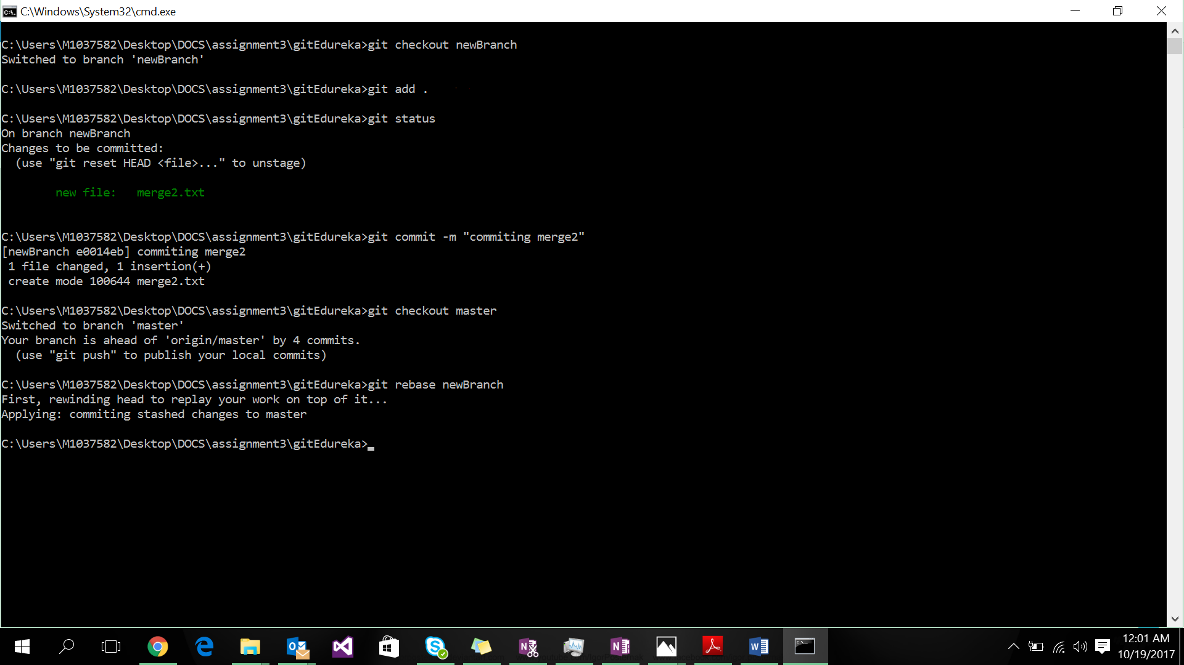

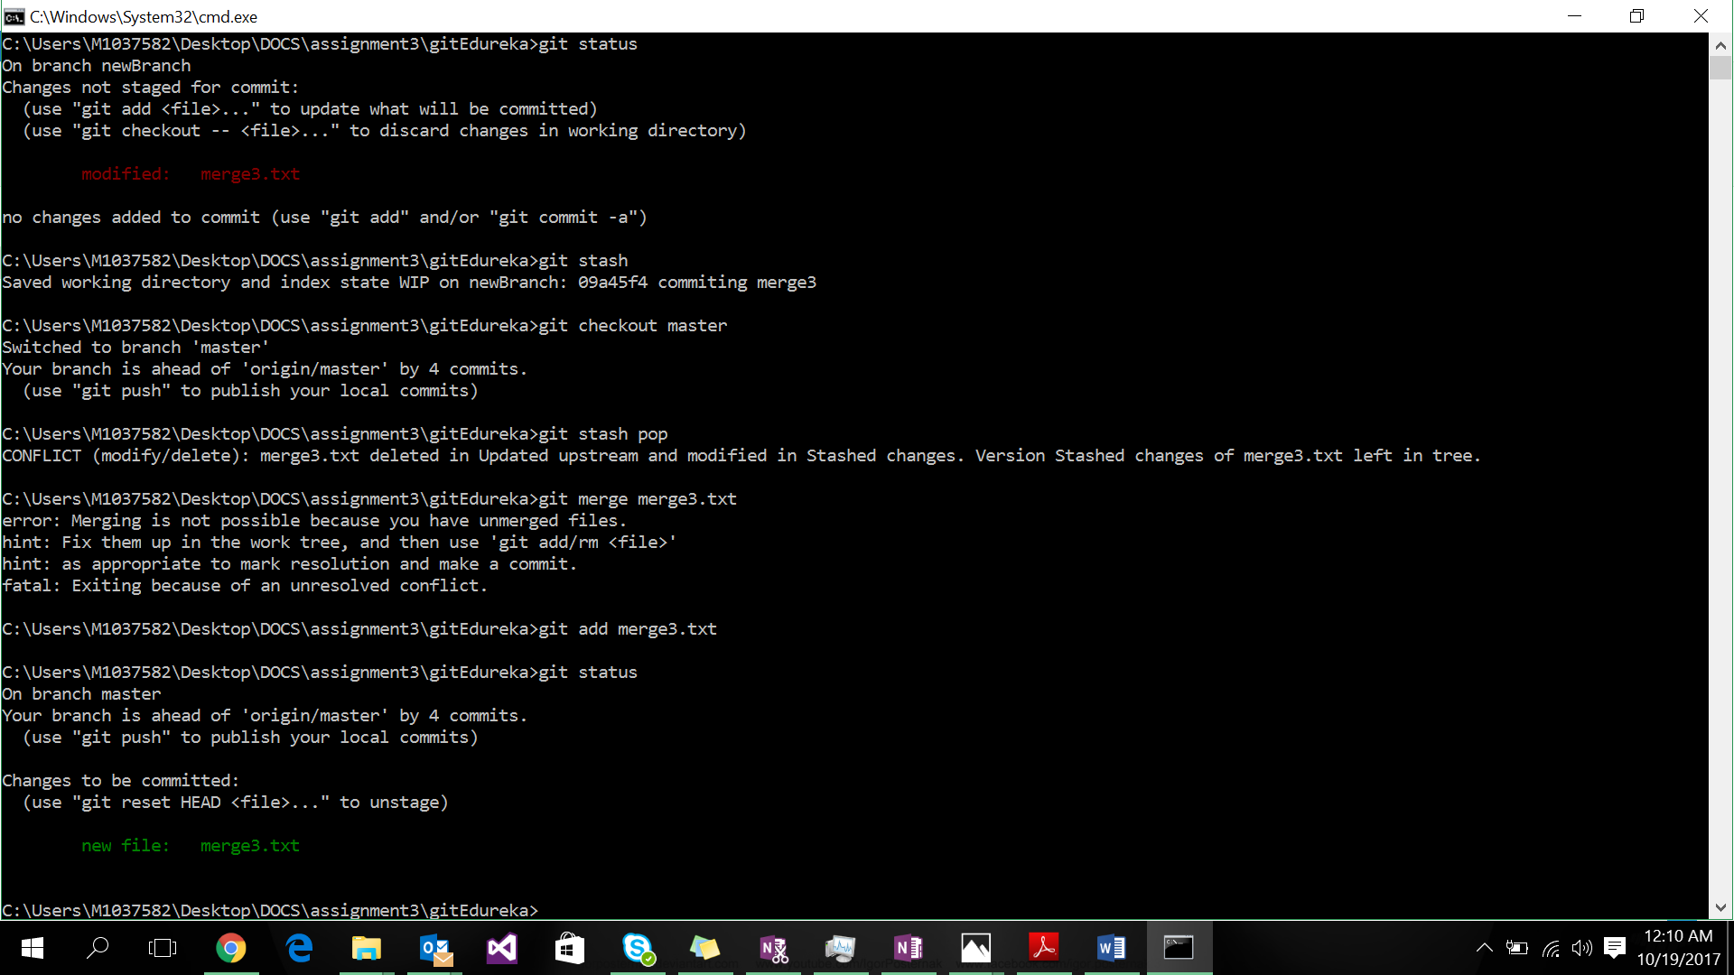

Q6. Push the local branch to the remote repository and see if the branch is present on the remote repository – Github